REQUEST FOR PROPOSAL (RFP)

Landscape Design Services

Wells Branch Community Library
RFP Issue Date: June 10, 2026
Proposal Due Date: August 9, 2026

1. INTRODUCTION
The Wells Branch Community Library is requesting proposals from qualified landscape architecture and/or landscape design firms to provide professional design services for the development of an exterior landscape improvement plan for the library located at:
15001 Wells Port Drive, Austin, Texas 78728
The Wells Branch Community Library District was created by election on August 8, 1998, soon after Texas legislation allowed the establishment of library districts in areas not served by existing library systems. The Library building was built in 2003 on land leased from the Wells Branch Municipal Utility District (MUD), but the Library is not funded or governed by the MUD or any other municipality. The Library District is funded primarily through sales tax and is governed by an elected board of five trustees.
The selected firm will work collaboratively with library administration and the Library Board management and landscape committee to develop a cohesive, welcoming, sustainable, and functional landscape design that supports community engagement and complements the library renovation project scheduled for completion in January 2027.

2. PROJECT BACKGROUND
Wells Branch Community Library is currently undergoing an exterior and interior library renovation project – the first major full renovation since the building was constructed. In conjunction with this renovation, the library intends to improve the surrounding exterior environment to create inviting and useful outdoor spaces for patrons of all ages.
The Library Board has not requested bids for landscape design since the original landscaping plan completed in January 2003 (included on page 6). The trees and plants currently on the Library site were planted in 2003-2004 based on this plan.
The Library Landscape Committee has collected input on the landscape design from Library staff, Library Board members, community groups, MUD Board members, and other stakeholders. The Landscape Committee envisions a landscape design that may include:
- Comfortable seating areas
- Shade structures
- Outdoor gathering and programming spaces
- Central Texas native plantings
- Accessible walking paths
- Areas for children and families
- Outdoor reading and quiet spaces
- Outdoor lighting and electrical improvements for improved staff/user safety and potential outdoor workspaces
- Enhanced curb appeal and community identity
- Irrigation and drainage considerations
- Opportunities for public art or interactive elements like a permanent story walk
The Wells Branch Community Library is a National Wildlife Federation Certified Wildlife Habitat. The landscape design must meet the criteria to maintain Wildlife Habitat certification.
The library seeks a consultant who can assist with both conceptual planning and implementation-ready design documents.

3. SCOPE OF SERVICES
The selected consultant will provide services that may include, but are not limited to:

Phase 1 – Site Evaluation & Visioning
- Review existing site conditions
- Meet with Library Landscape Committee
- Review stakeholder input collected by Landscape Committee
- Conduct site visits and analysis
- Assess drainage and irrigation with the MUD
- Assess shade, circulation, and usability
- Develop conceptual ideas and preliminary recommendations
- Share preliminary concepts with Landscape Committee for feedback

Phase 2 – Landscape Design Development
- Prepare conceptual landscape plans
- Develop planting palettes and material recommendations
- Recommend furnishings, lighting, and hardscape elements
- Incorporate sustainability and maintenance considerations
- Ensure ADA accessibility compliance

Phase 3 – Construction Documentation
- Prepare detailed design and construction documents
- Provide installation cost estimates and phased implementation options
- Assist with Installation bid package preparation if requested
- Prepare a landscape maintenance plan

Optional Services
- Presentation to Library Board
- Construction administration services

4. PROJECT TIMELINE
The anticipated schedule is as follows:
Milestone | Estimated Date
RFP Issued | June 10, 2026
Questions Due | July 20, 2026
Proposal Submission Deadline | August 9, 2026
Consultant Selected | August 11, 2026
Design Work Begins | Late August 2026
Final Design Completion | September 30, 2026
Estimated Construction Start | February 2027
The library reserves the right to modify this timeline as needed.

5. PROPOSAL REQUIREMENTS
Proposals should include the following:

Firm Information
- Company name and address
- Primary contact person
- Years in business
- Relevant certifications/licenses

Project Experience
Provide examples of similar projects, particularly:
- Libraries
- Public spaces
- Educational facilities
- Community-focused landscape projects
- Central Texas Native plant-focused projects including those with Wildlife Certification
Include photos or project summaries if available.

Project Approach
Describe:
- Design philosophy
- Proposed process and timeline
- Sustainability practices

Project Team
Identify key personnel and their roles and qualifications.

References
Provide at least three professional references from similar projects.

Fee Proposal
Provide:
- Proposed fee structure for landscape design services
- Proposed fee structure for landscape installation services
- Hourly rates if applicable
- Estimated reimbursable expenses
- Optional services pricing

6. EVALUATION CRITERIA
Proposals may be evaluated based on:
- Relevant experience
- Quality of previous work
- Understanding of project goals
- Creativity and functionality of approach
- Ability to meet timeline and budget
- References
- Cost proposal

7. SUBMISSION INSTRUCTIONS
Proposals must be submitted no later than August 9, 2026.
Submit electronically to the Wells Branch Library Board Landscape Committee members:
- Jennifer Klein, Board Trustee: jenniferk@wblibrary.org
- Elizabeth Martin, Board Trustee: elizabethm@wblibrary.org
- Dayna Williams, Assistant Executive Director: dayna@wblibrary.org
OR mail/deliver to: 15001 Wells Port Drive, Austin, Texas 78728
Late submissions may not be considered.

8. QUESTIONS
Questions regarding this RFP should be directed to:
Wells Branch Community Library Board Landscape Committee
- Jennifer Klein: jenniferk@wblibrary.org
- Elizabeth Martin: elizabethm@wblibrary.org
- Dayna Williams: dayna@wblibrary.org
Questions must be submitted by July 20, 2026.

9. RESERVATION OF RIGHTS
The library reserves the right to:
- Reject any or all proposals
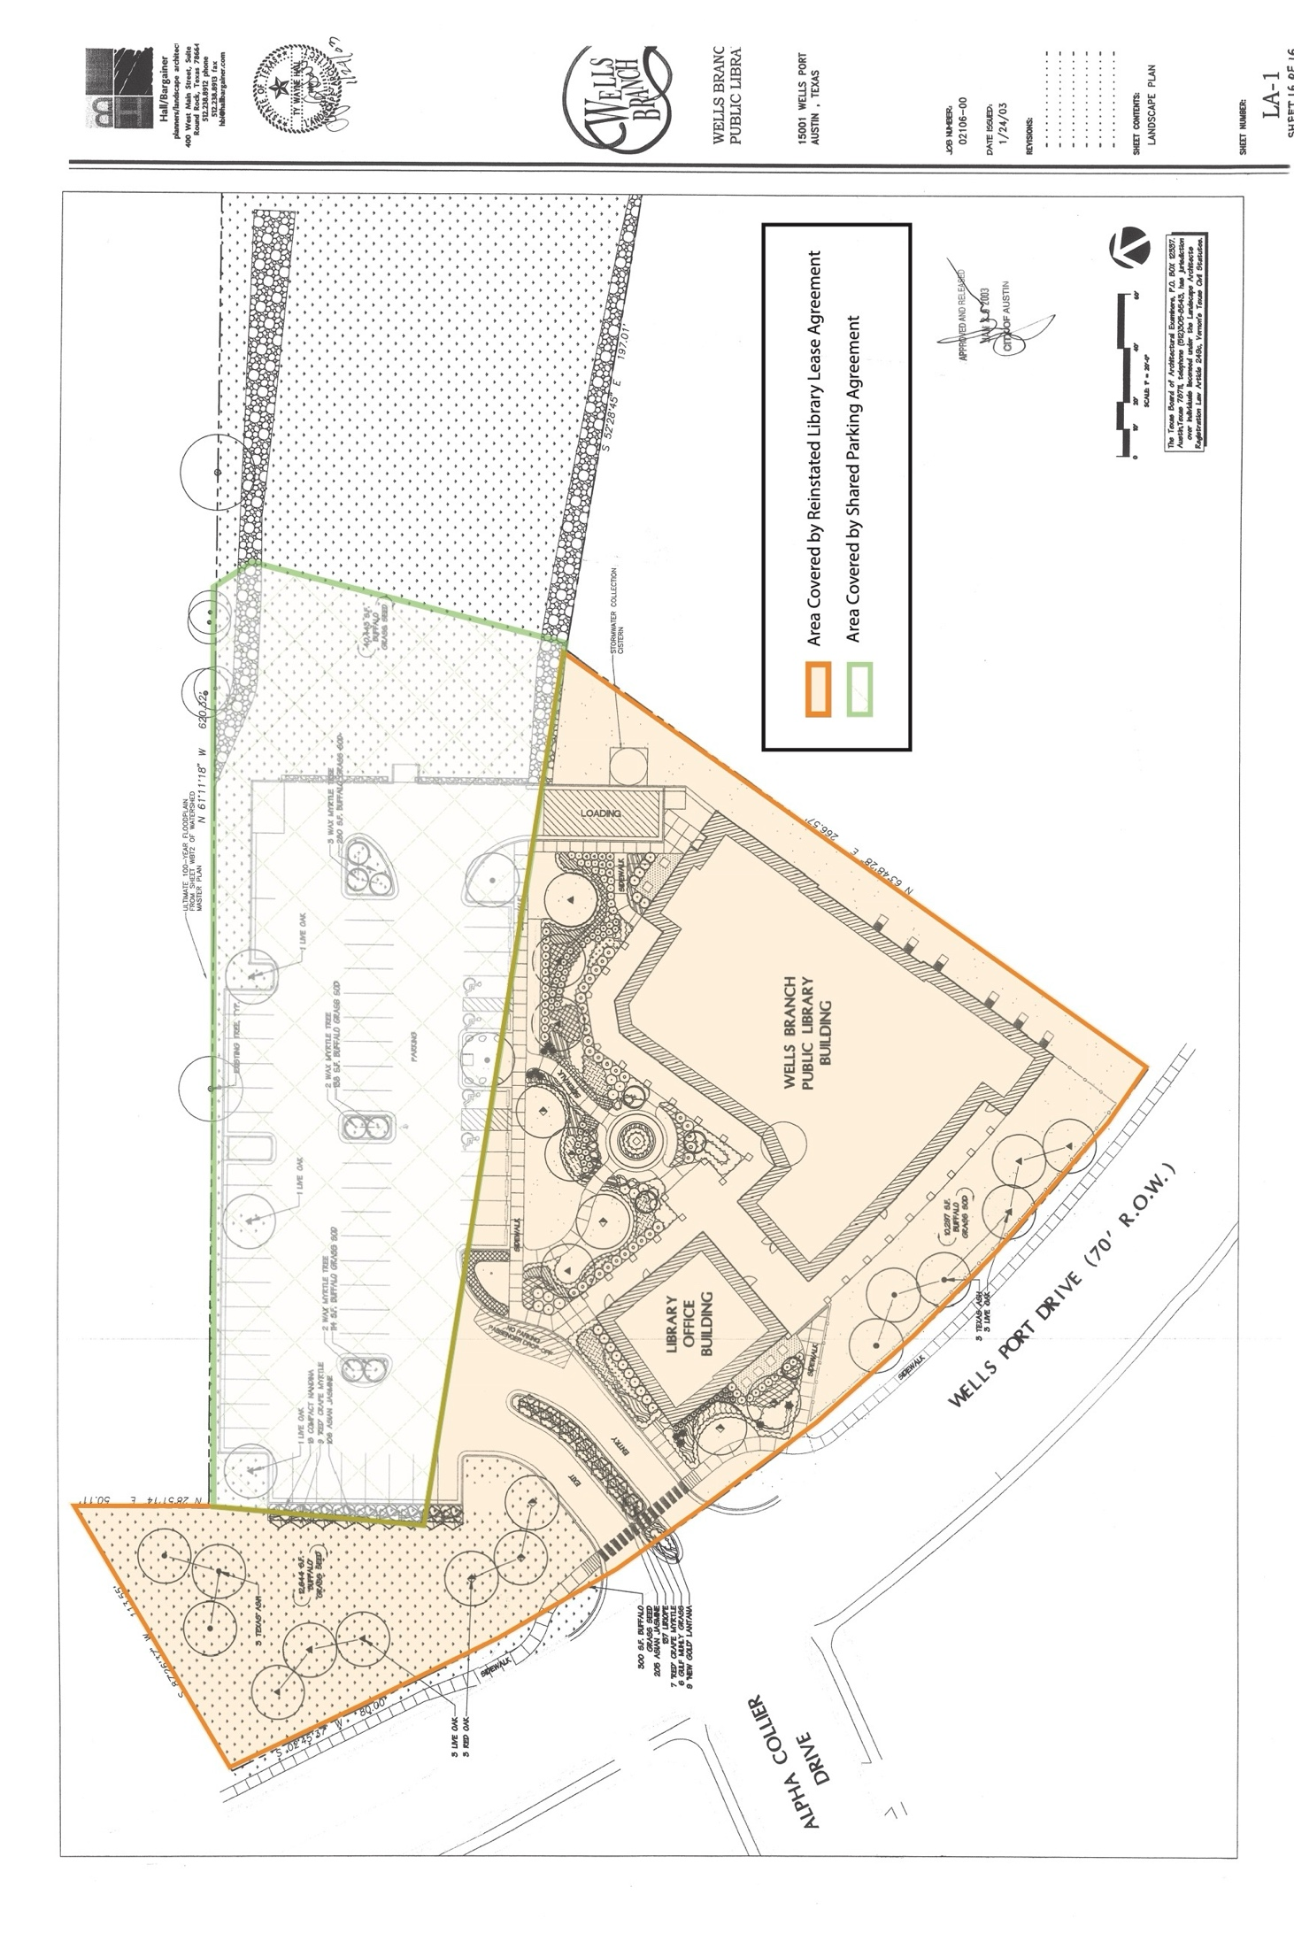
- Waive informalities or irregularities nal infor

